List of Reading Material

- https://goodfileshare.com/the-flavor-bible-pdf
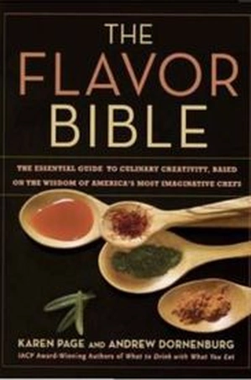

- https://doi.org/10.1177%2F1071181319631347
An Eye-Tracking Analysis of a Restaurant Menu
Joshua K. Smith, Jacob D. Guliuzo, Jacob D. Benedict

- https://doi.org/10.1002/jcpy.1231

Dipayan Biswas, Lauren I. Labrecque, Donald R. Lehmann. Effects of Sequential Sensory Cues on Food Taste Perception: Cross‐Modal Interplay Between Visual and Olfactory Stimuli.

